Dear Alamosa Readers,

Feel free to customize this letter to your goals and kick start your fundraising efforts with friends and family. We hope your have an amazing reading adventure!

************************************

Dear ________________ ,

I’m excited to share that my school, Alamosa Park Elementary is hosting its first-ever Read-a-Thon. Between the weeks of February 16 - March 2, me and my school mates will be challenged to read as much as possible. We will work to earn individual, class and school-wide prizes. If we reach our school goal of $10k our entire school will receive a HUGE HAWK SURPRISE!

I’ve given much thought to how much reading I can accomplish during this time and during the 15 days, I’ve set out to read ___________ minutes a day which is _____________ minutes in total! I might even read more than that!

Would you be able to make a pledge and sponsor me in my read-a-thon? You could calculate your donation based on the minutes I’ve pledged above or a flat amount. Once the read-a-thon is over, I’ll be sure to let you know how well I did.

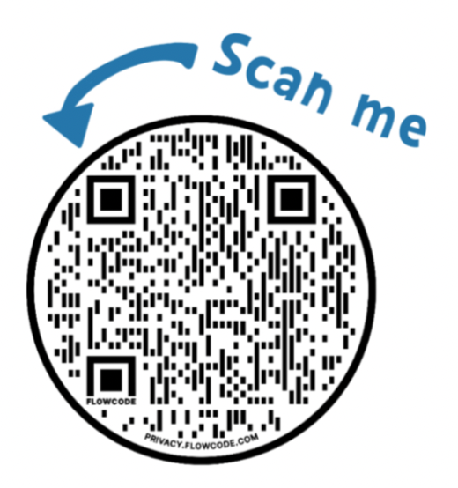
All the money we raise will help fund digital programs, field trips, and other enrichment programs that benefit every student at Alamosa Park Elementary School—including me!

If you are interested in sponsoring me, please visit our Pledge website at www.alamosaedfoundation.com/read-a-thon.html or scan our QR code.

Thank you for your consideration in supporting me and my school, Alamosa Park Elementary.

Sincerely,

______________________

